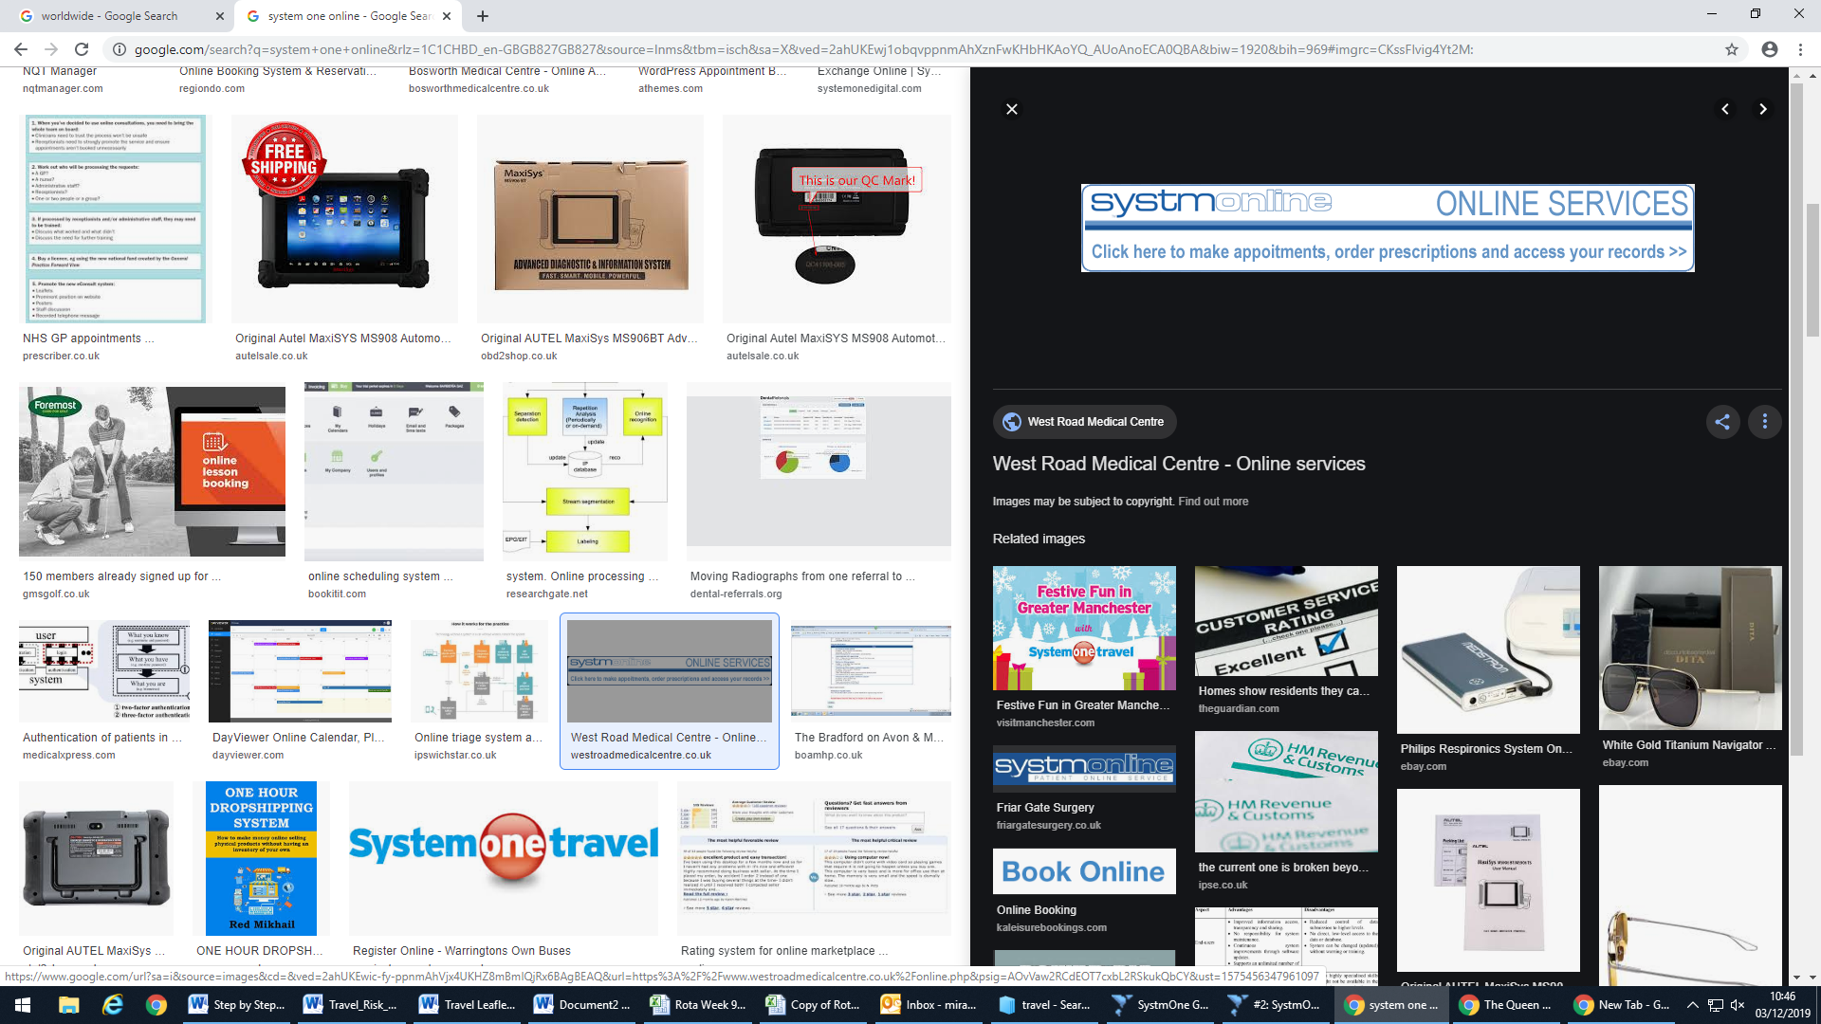

You can view your vaccination history online – ask at reception for you login details

**Please make sure you have photo ID**

You can also research online about vaccinations:

[www.fitfortravel.nhs.uk](http://www.fitfortravel.nhs.uk)

www.nhs.uk>LiveWell>Healthybody



picture of eiffel tower

* Form passed to the nurse
* The nurse to look through your records
* **Please allow at least a week for the above process**
* Patient to call the surgery to find out the vaccinations recommended
* Either book an appointment at the travel clinic or here at the medical practice
* **If you are travelling within a month please be aware we may not be able to offer an appointment**
* **Malaria tablets you can obtain from Kays Chemist (no prescription from us is needed)**
* **Any private vaccinations will not be done here, you will need to go to a travel clinic**

Now that you have completed your risk assessment form, this will be passed to the nurse.

The nurse will then look through you medical records in detail to ensure that all information reported back to you is correct.

### **The Queen Edith Medical Practice**

59 Queen Edith's Way

Cambridge

CB1 8PJ

CAPCCG.generalqemp@nhs.net

# Travel Vaccinations